Capstone Project Submission Report

1. Project Title
- Azure Cloud Data Engineering for BFSI: Scalable ETL and Real-Time Analytics Solution

2. Student Information
- Name: Prateek Baisla
- Student ID: 127232
- Course/Program: Data Engineering Training
- Instructor Name: Mr. Piyush

3. Problem Definition and Objectives

Problem Definition:

The fictional financial institution processes millions of transactions daily and needs to analyze this data for fraud detection, risk assessment, and regulatory compliance. The institution requires a scalable, secure, and cost-optimized solution for ingesting, transforming, and storing data from various sources, including banking APIs, structured databases, and event-driven streams.

Objectives:

Ingest Historical and Real-Time Data: Ingest data from both historical (CSV/Parquet) and real-time (JSON messages) sources.

Data Transformation: Clean, normalize, and transform the data for analysis.

Data Storage: Securely store the transformed data in Azure SQL Database and Azure Cosmos DB.

Real-Time Processing: Process real-time transaction data to trigger alerts for suspicious activities.
- Optimization: Ensure high availability, scalability, and cost optimization.

Medallion Architecture Approach:

I have adopted the Medallion Architecture; a design pattern used for organizing data processing in data lakes and data warehouses. This approach allows for scalable, reliable, and organized data processing while ensuring data quality and governance. Here are the key layers I implemented:

- Bronze Layer (Raw Data):
  - This layer holds raw, unprocessed data.
  - Stores data as received from various sources without any transformations.
  - Acts as a single source of truth for raw data.
- Silver Layer (Cleaned and Enriched Data):
  - This layer contains data that has been cleaned and enriched.
  - Involves data transformation, validation, and combining data from different sources.
  - Makes data more accessible and usable for analysis.
- Gold Layer (Aggregated Data):
  - This layer holds aggregated and summarized data.
  - Optimized for analytics and reporting purposes.
  - Data is organized for specific business use cases, such as fraud detection, customer behavior analysis, and regulatory compliance.

Bronze Layer (Raw Data):

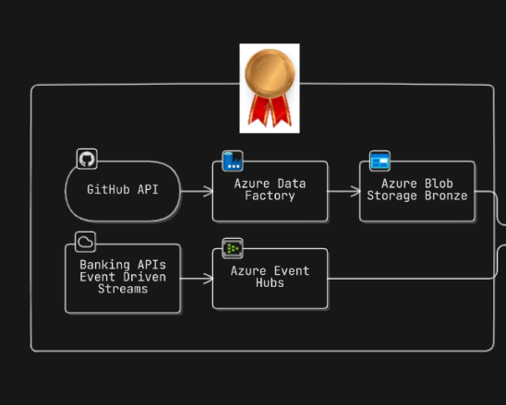

Silver Layer (Cleaned and Enriched Data):

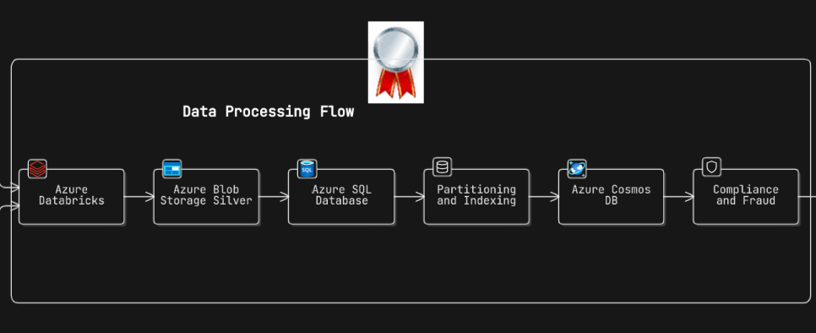

Gold Layer (Aggregated Data):

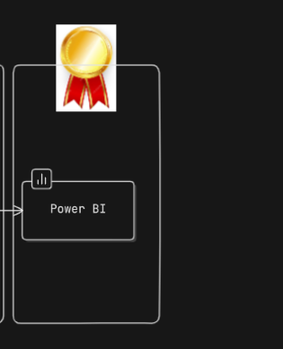

Architecture: High-Level Overview of Problem Context

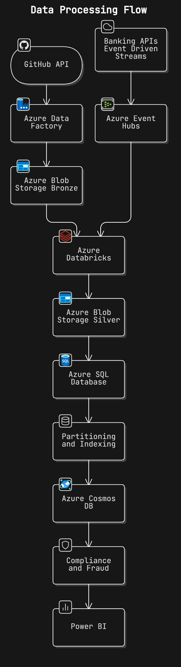
Mid - Report

Data Ingestion (15 Marks):
I dynamically ingest historical data from GitHub API and HTTP link directly into Azure Blob Storage using Azure Data Factory.

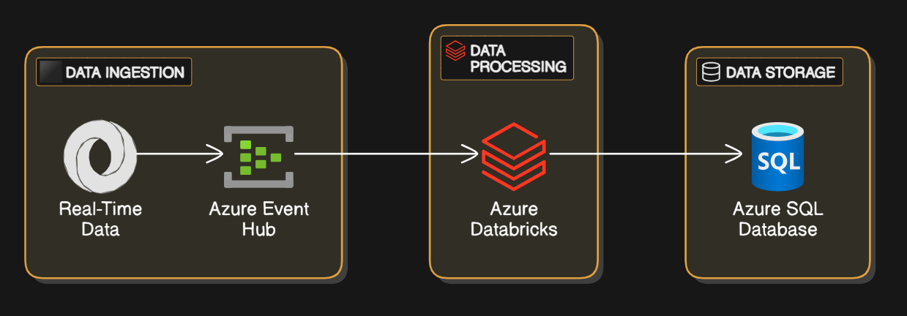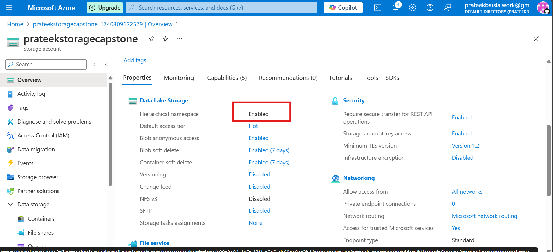
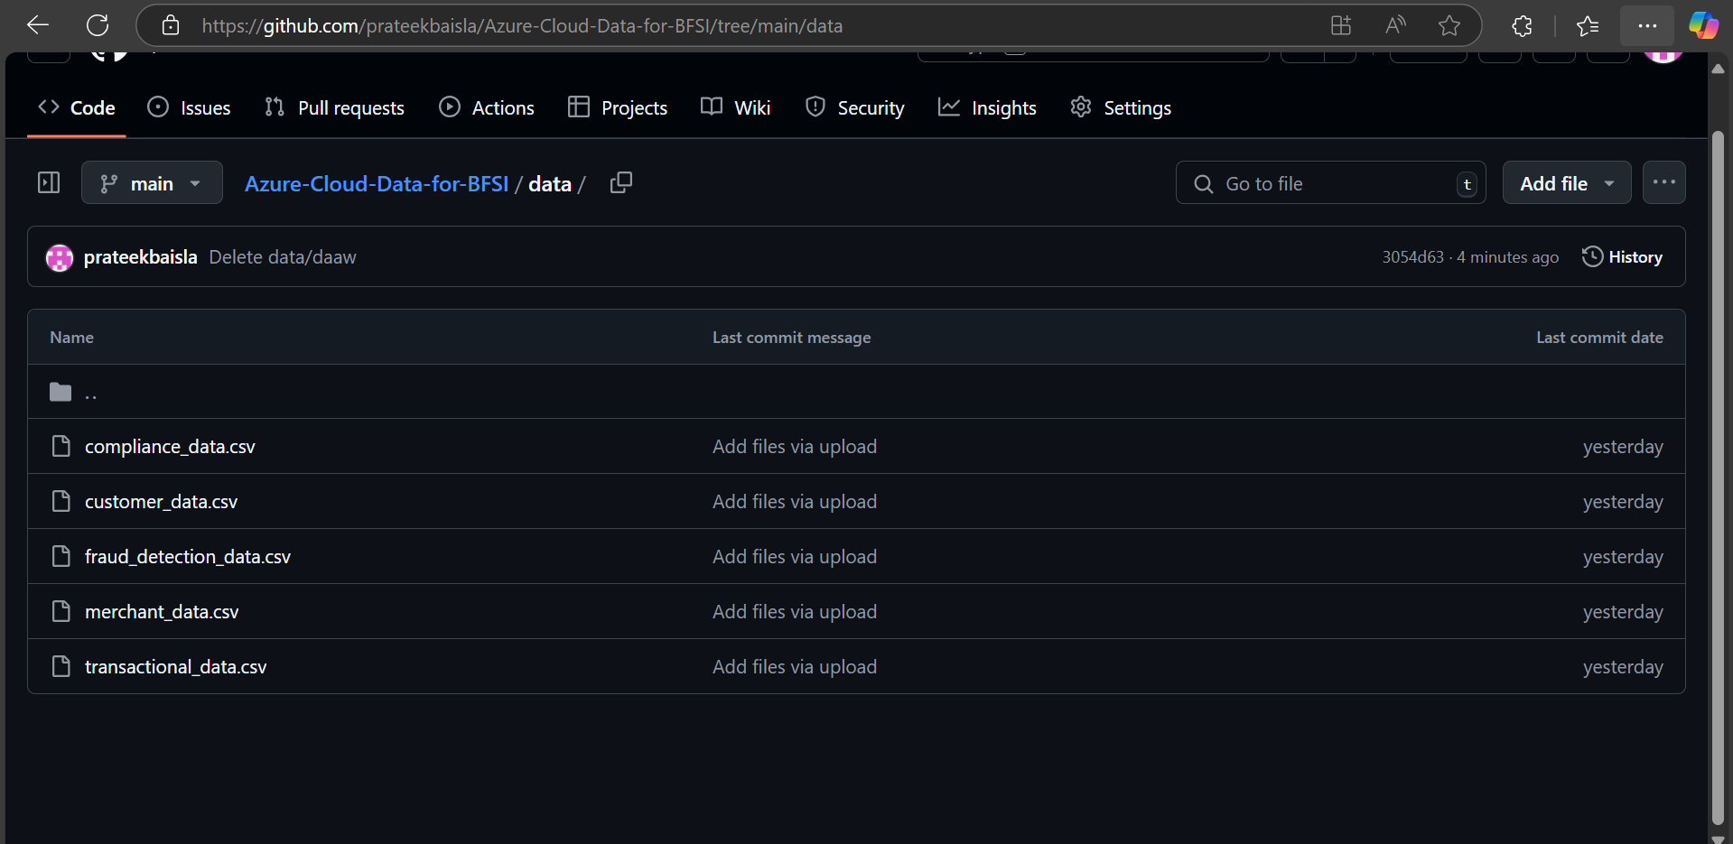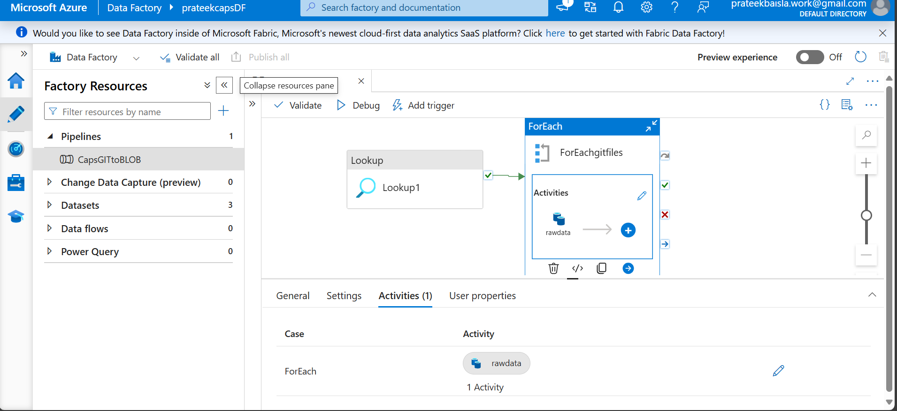
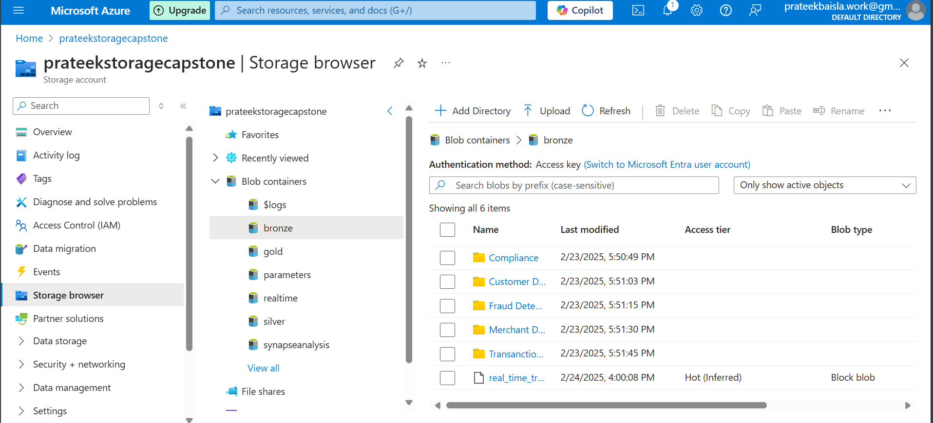
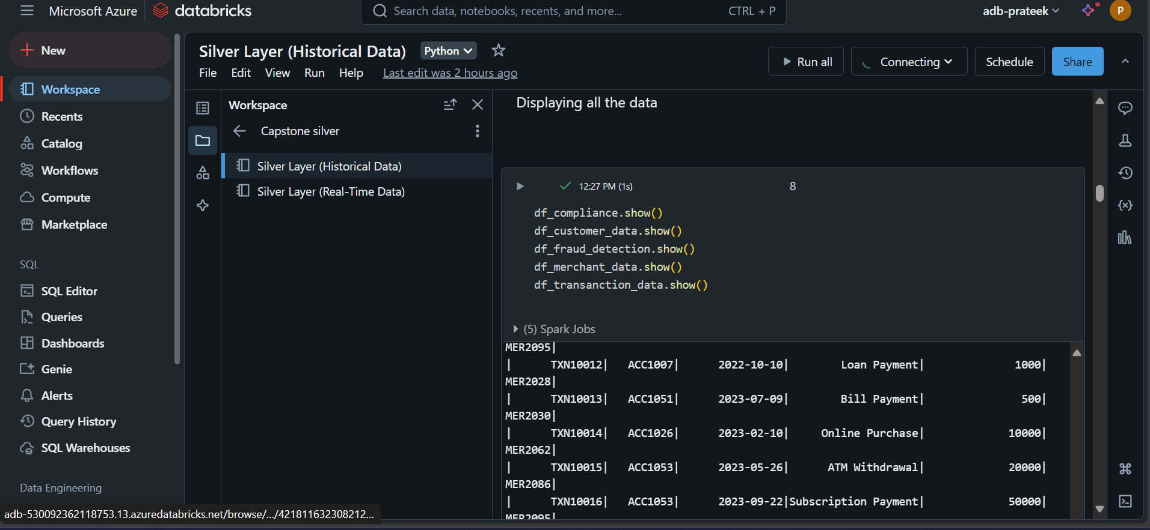

I set up real-time data streams using a Python producer to send data into Event Hub, which is then integrated with Data bricks.
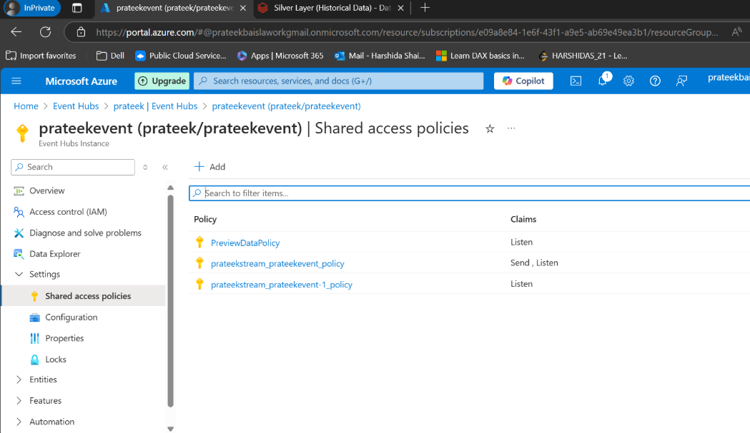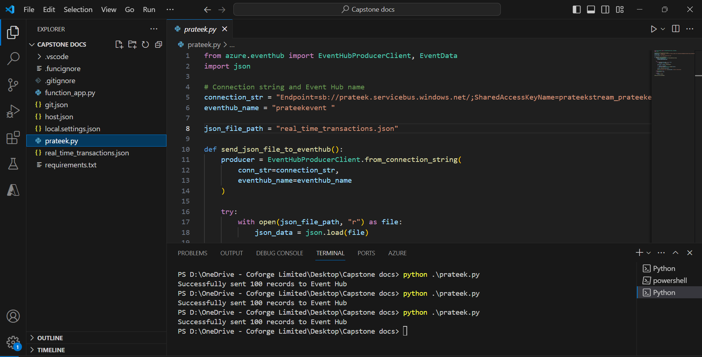

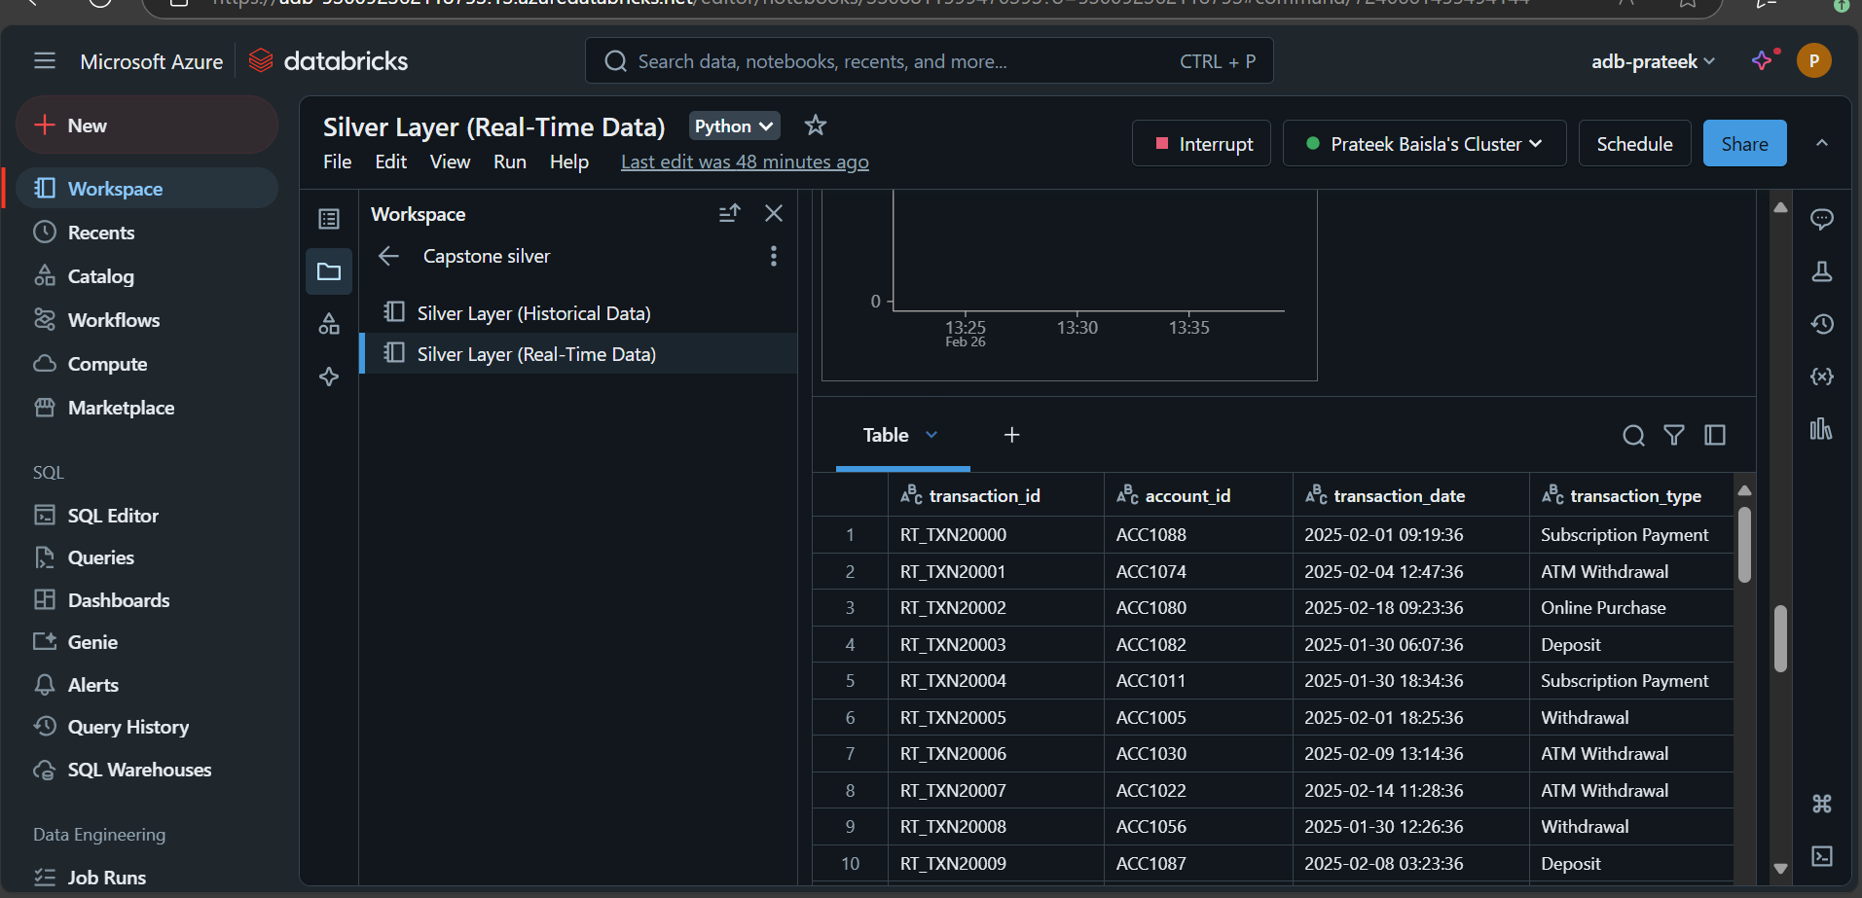

Table: Data Description
I ensure data is ingested from both historical and real-time sources without loss.
Attribute Name | Data Type | Description | Missing Values (%)
transaction_id | Integer | Unique ID for a transaction | 0%
account_id | Integer | Unique ID for an account | 0%
transaction_date | Date | Date of transaction | 0%
transaction_amount | Float | Amount of transaction | 0%
transaction_type | String | Type of transaction | 0%
merchant_id | Integer | Unique ID for a merchant | 0%

Data Transformation (15 Marks):

I clean and transform data using Azure Data bricks, correcting invalid data, standardizing data types, and filling missing values.
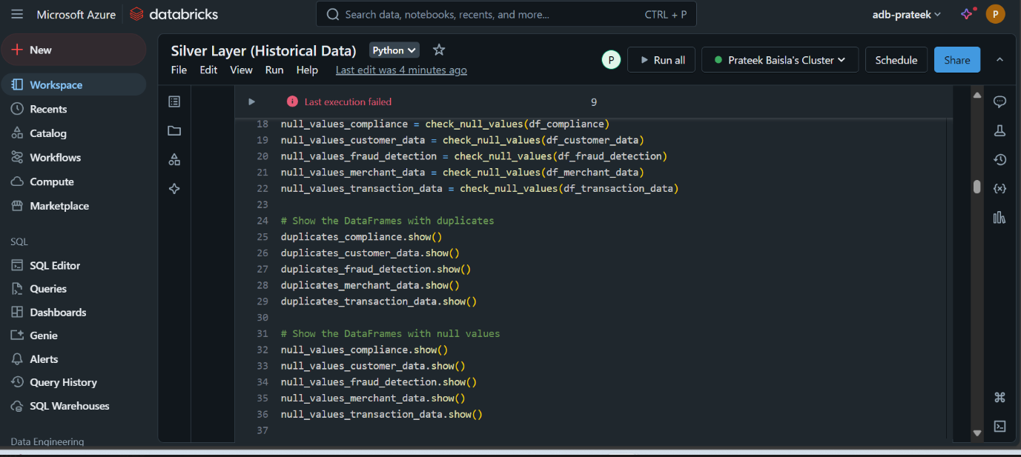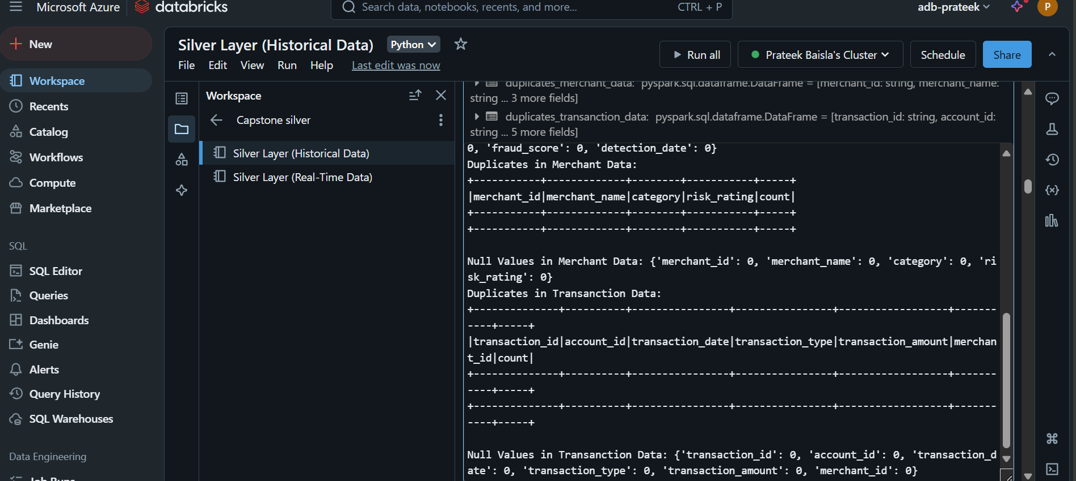

I perform basic aggregations and some data analysis

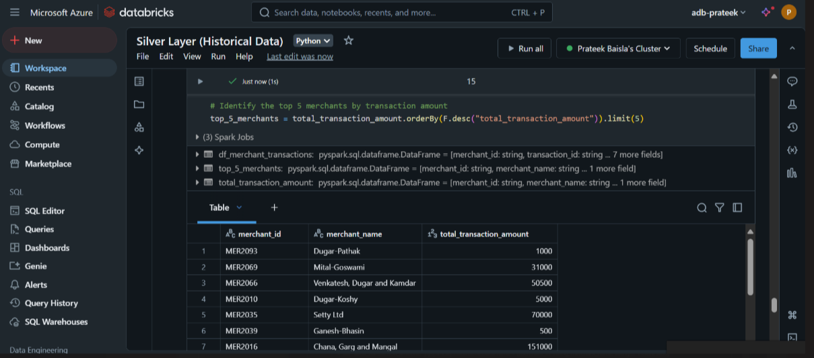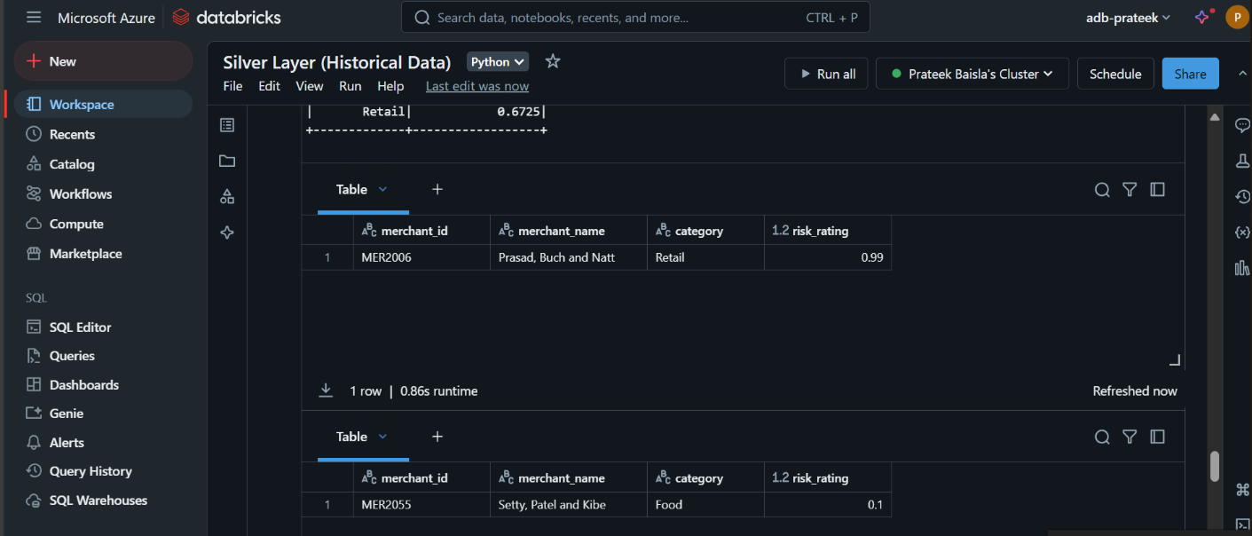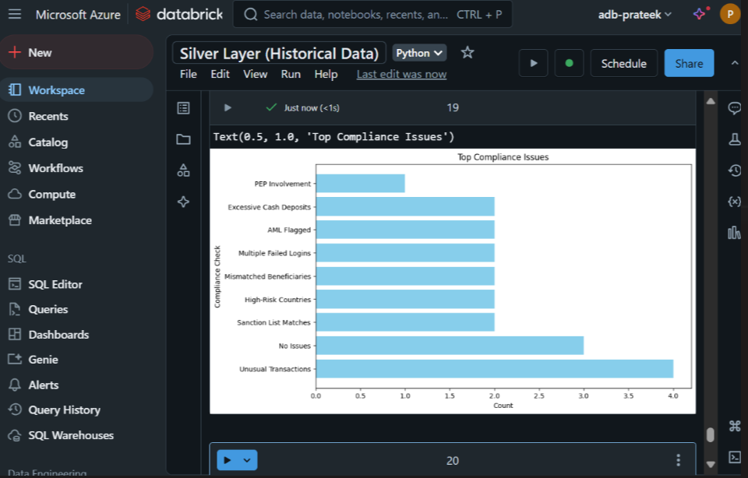 Data Preprocessing:

Steps included handling missing data with mean imputation, normalizing data using Min-Max normalization, and feature engineering.

Table: Data Preprocessing Summary
Step | Technique | Result
Handle Missing Data | Mean Imputation | No Missing Data
Feature Scaling | Min-Max Normalization | Scaled between 0-1

Data Storage (10 Marks):

I store the transformed data in Azure SQL Database and Azure Cosmos DB.

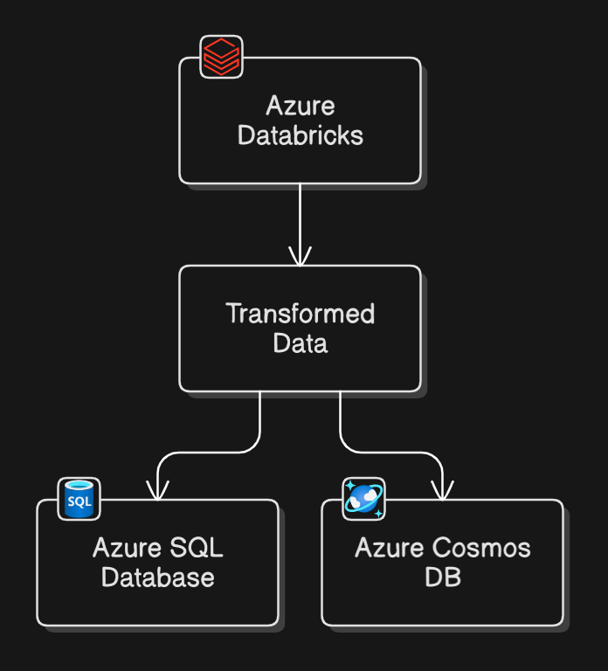
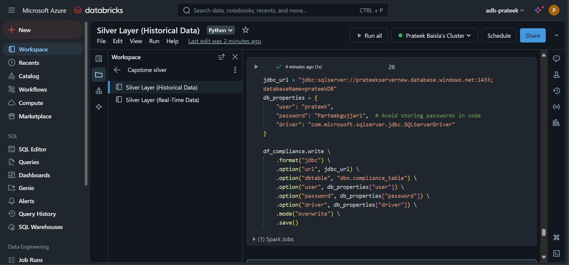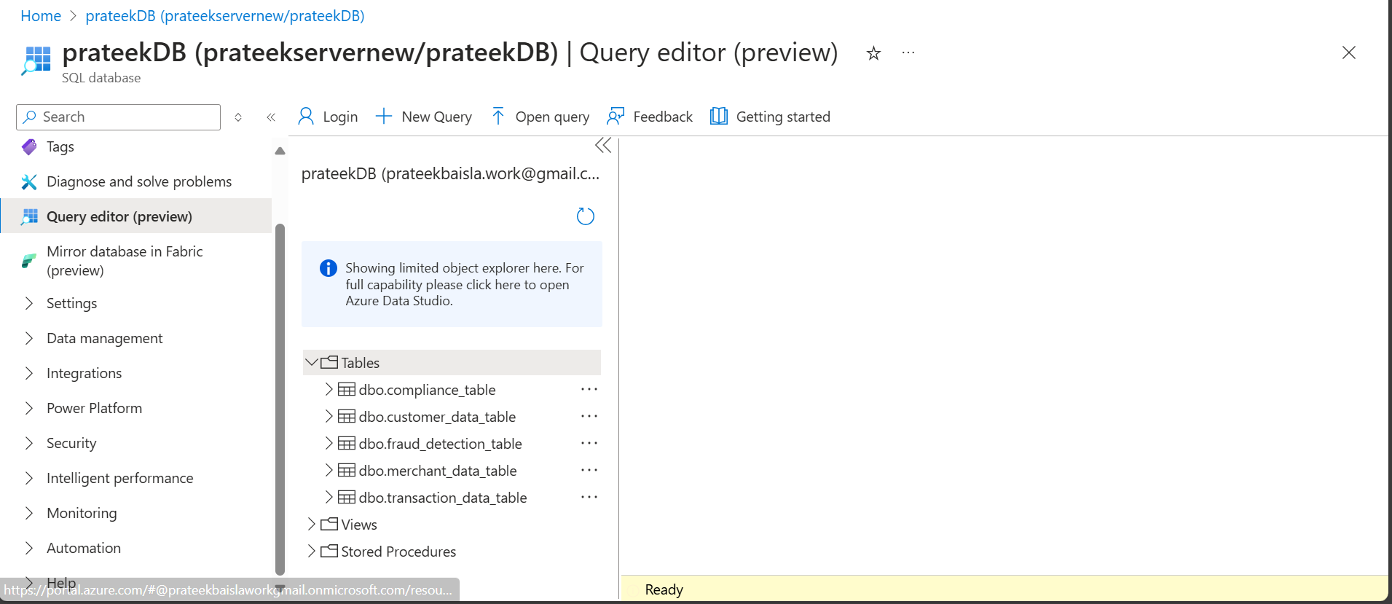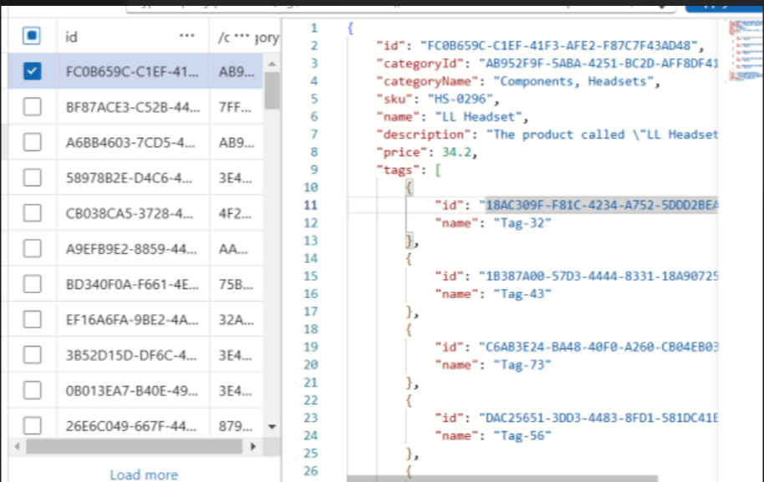

I ensure proper partitioning and optimization for query performance.

Ensure proper partitioning and optimization for query performance.

Partitioning & Indexing Strategies:
Optimization Technique | Purpose | Benefit
Partitioning | Split datasets | Improved query performance
Indexing | Key columns indexed | Faster data retrieval

Basic Real-Time Data Processing (10 Marks):

I set up Azure Data bricks for processing real-time transaction data from Azure Event Hub.

I trigger basic alerts (e.g., suspicious transactions) and store real-time data in Azure SQL.

Triggering Events:
Event Type | Trigger Condition | Action/Outcome
Data Arrival | New data added | Start processing
Threshold Breach | Metric exceeds limit | Send alert

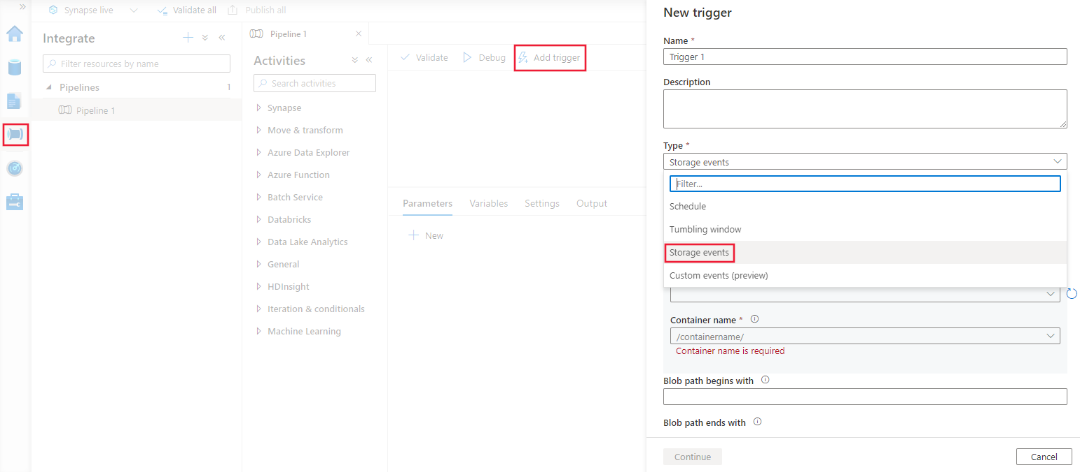

Exploratory Data Analysis through Power BI:

Patterns and trends were discovered, such as peak transaction times and common transaction types.
Peak Transaction Times
- Monthly Peaks: Certain months like January, February, and December seem to have higher transaction volumes.
- Date Peaks: Dates like the 10th, 22nd, and 27th appear to have multiple transactions.
Common Transaction Types
- Bill Payments and Loan Payments are frequent, indicating regular monthly expenses.
- Withdrawals and Deposits are also common, which shows active account management.
- Subscription Payments appear periodically, suggesting recurring services.
High-Value Transactions
- Deposits: Highest value recorded is ₹200,000.
- Loan Payments: Amounts of ₹200,000 are seen, likely reflecting major debt payments.
Frequent Merchants
- MER2071, MER2095, MER2012: These merchants appear multiple times, indicating regular transactions with these entities.
Patterns in Amounts
- Round Numbers: Many transactions are in multiples of ₹500 or ₹1000.
- High-Value Withdrawals: Withdrawals of ₹50,000 and ₹70,000 are notable.

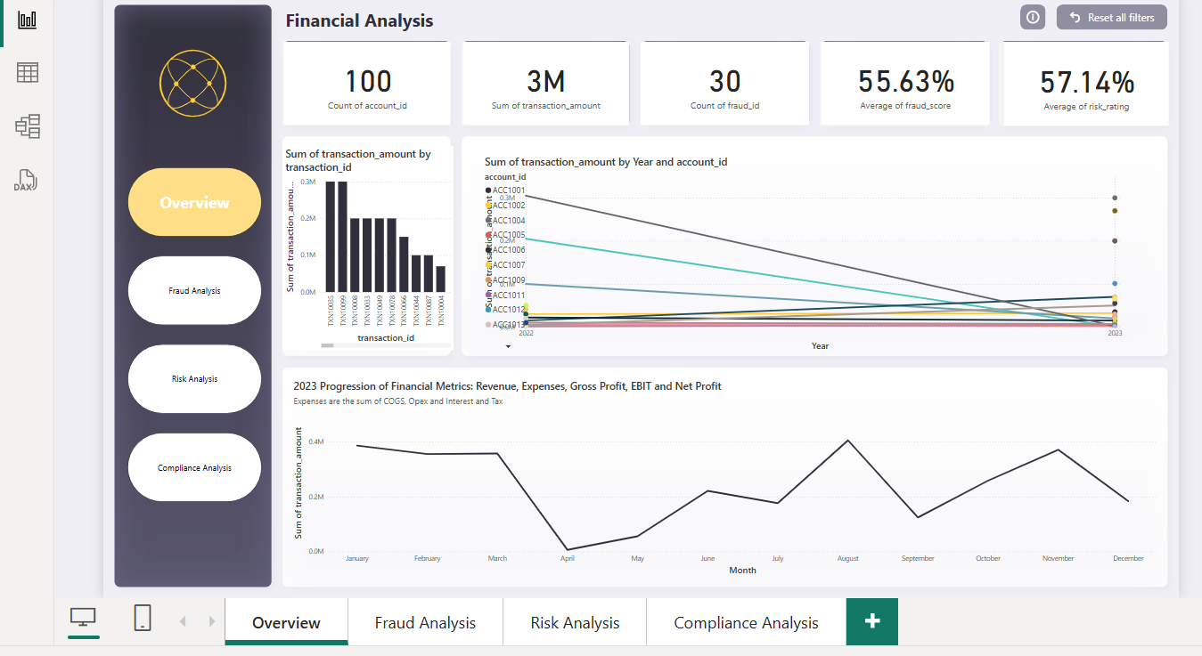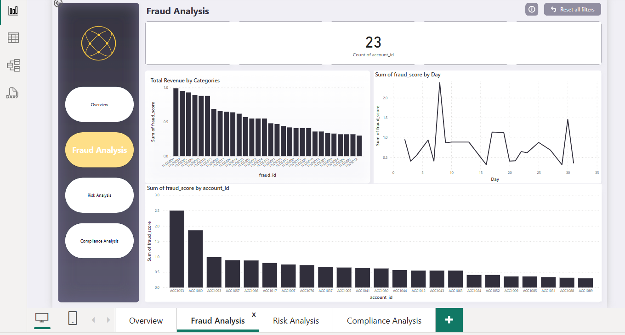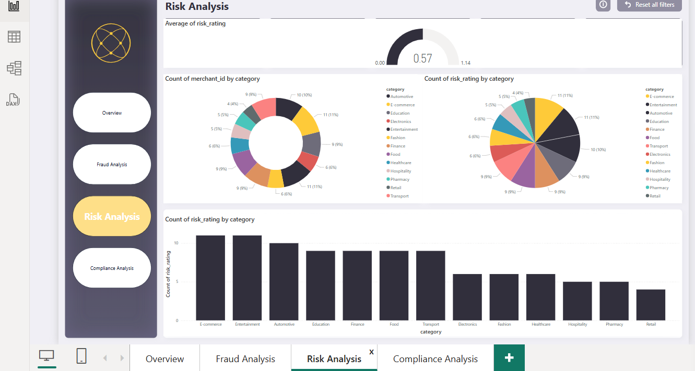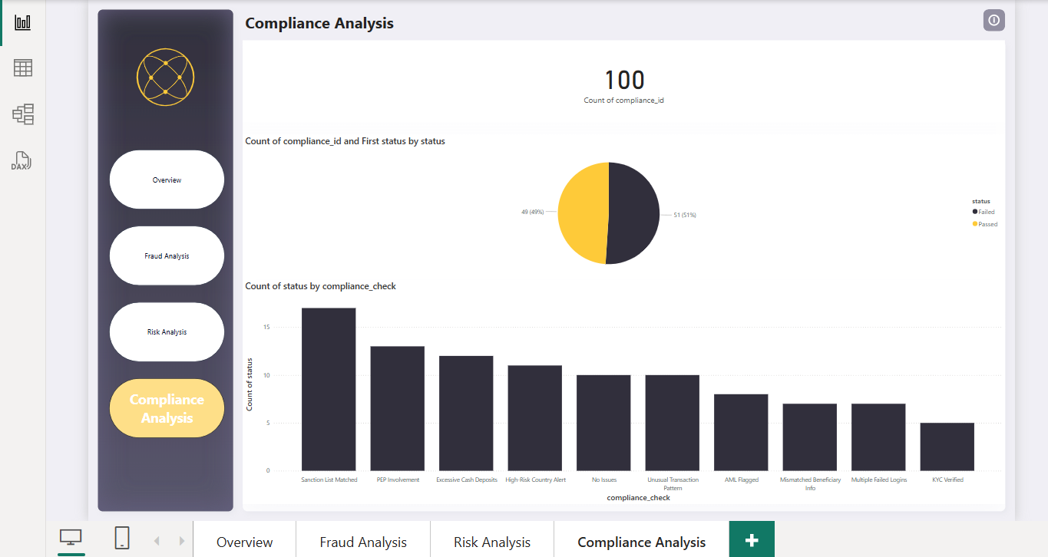

Final Report
For the Final Report, I focus on real-time processing, advanced analytics, and reporting.
User Stories:
- Real-Time Data Processing and Alerts (10 Marks):
  - I set up real-time processing of transaction data using Azure Stream Analytics or Data bricks.
  - I use a Python producer to send data into Event Hub, which is then integrated with Data bricks.
  - I analyze, filter, and trigger notifications for specific events (e.g., fraudulent transactions).
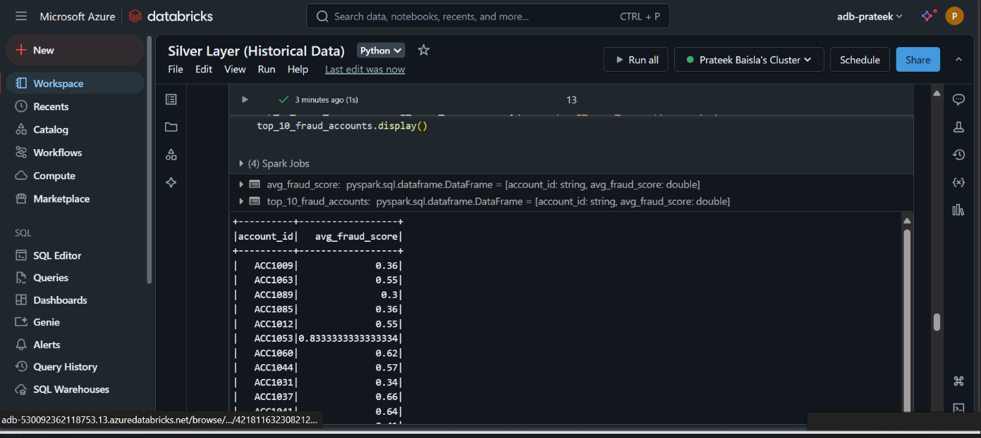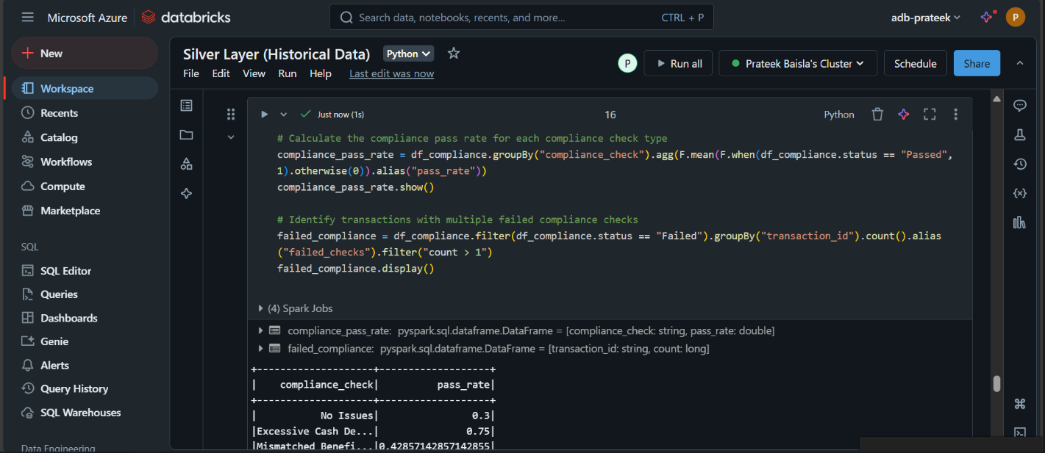
- Advanced Analytics and Forecasting (10 Marks):
  - I use Azure Synapse Analytics for advanced analytics and forecasting.

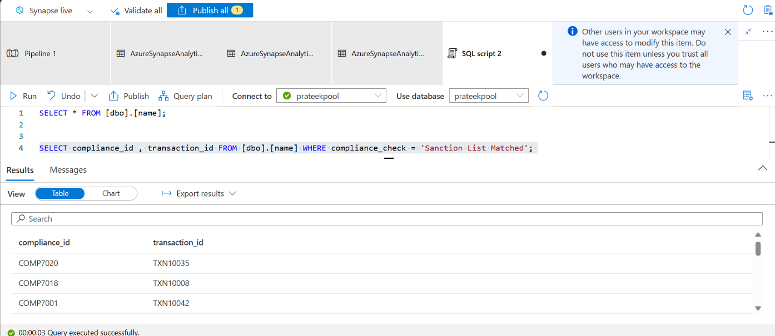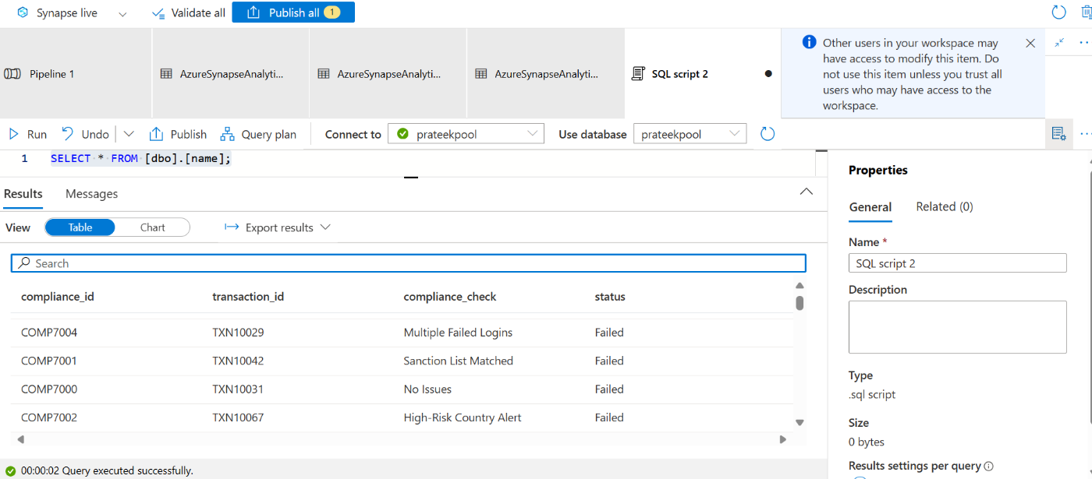
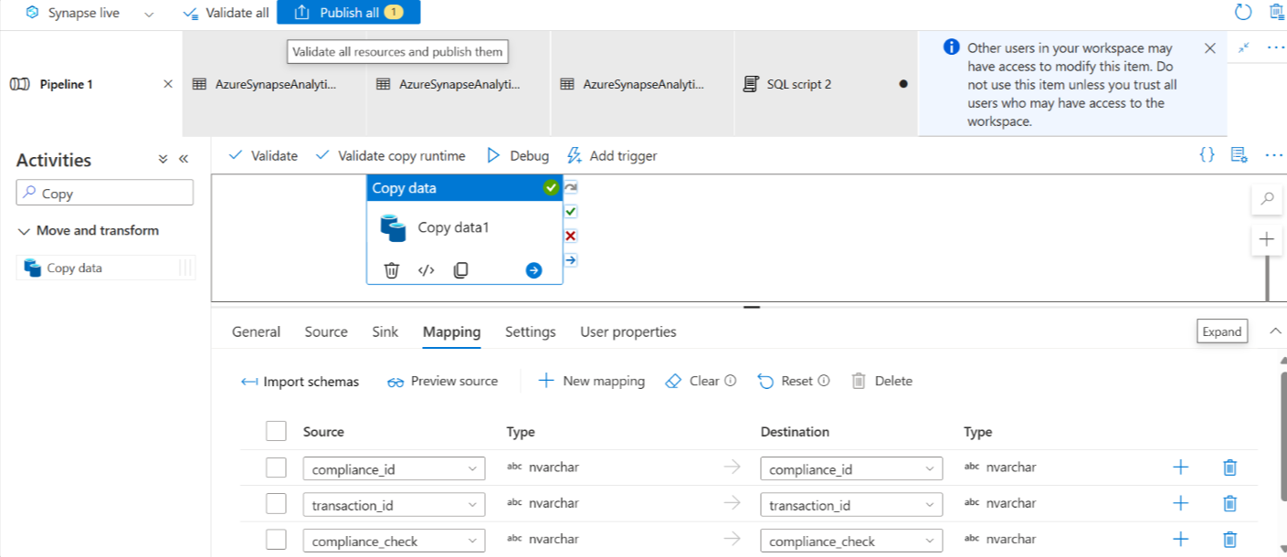

  - I build predictive models (e.g., fraud detection, customer churn prediction) using Azure Machine Learning.

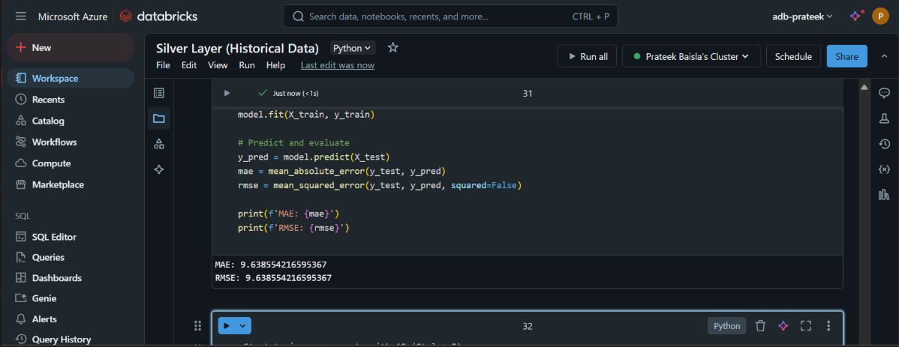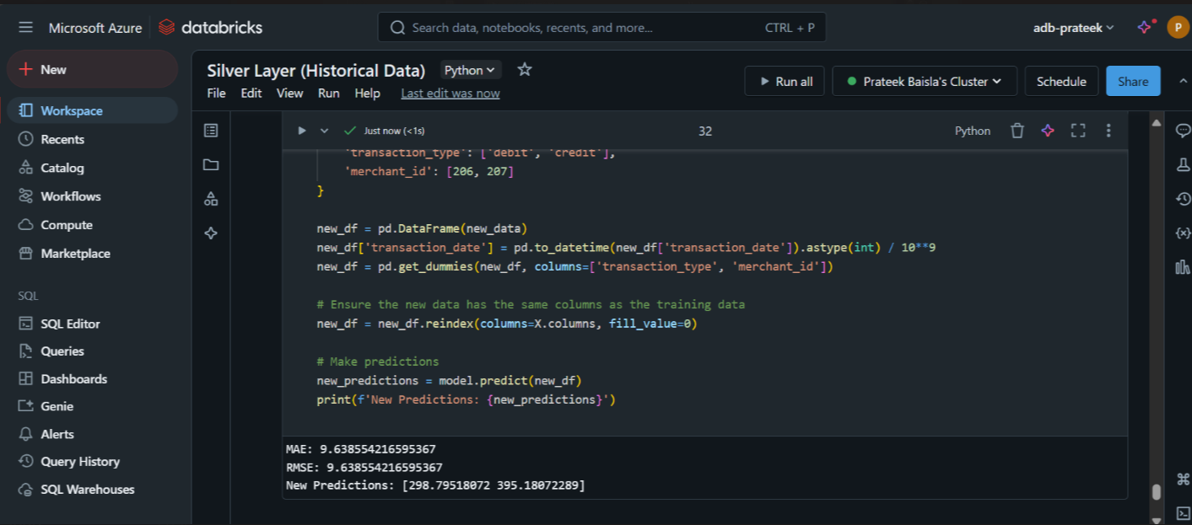

  - I integrate machine-learning models into the data pipeline using Azure Data Factory for scheduled reporting.
- Reporting and Dashboards (10 Marks):
  - I create Power BI dashboards that display real-time and historical transaction data.

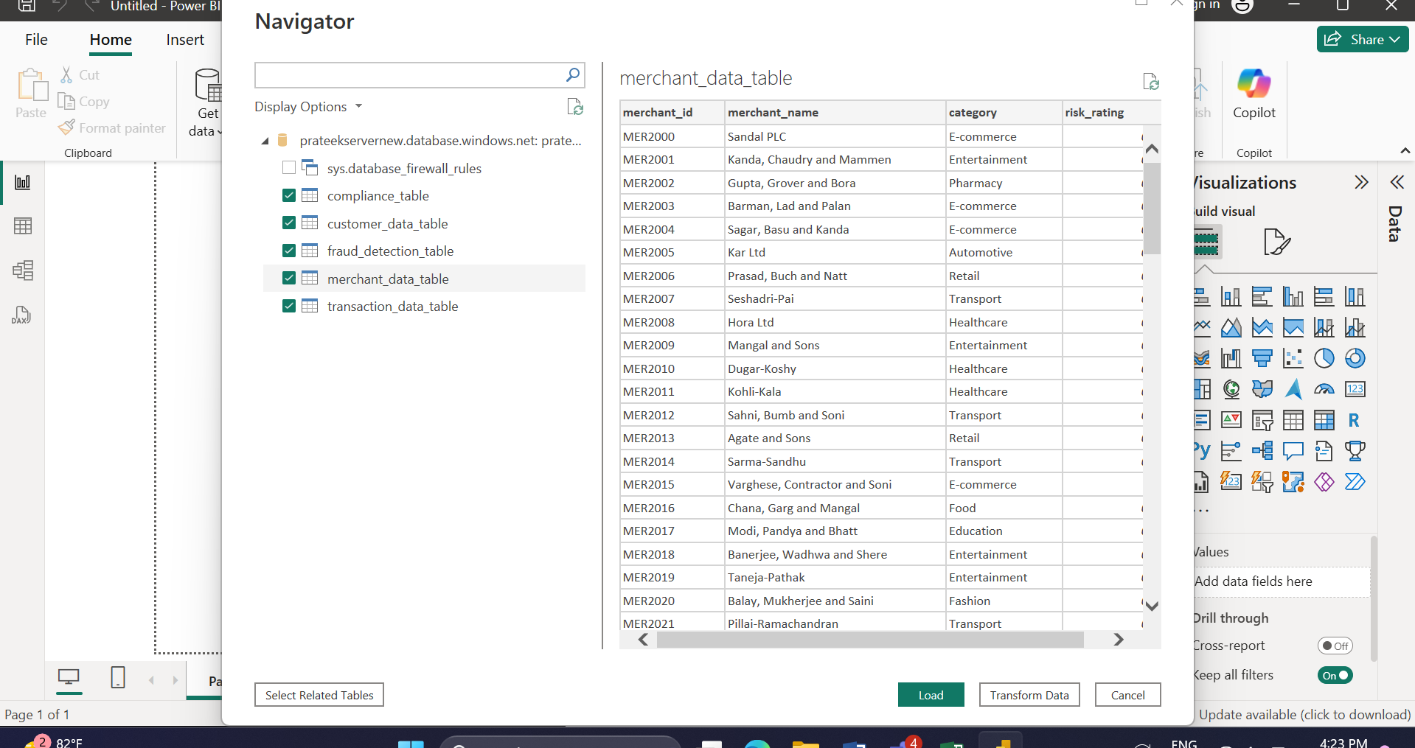

  - I show customer analytics, such as segmentation and risk assessment insights, as well as merchant performance metrics.

8. Analysis and Results

